What families need to know about LPS Food and Nutrition SY 21-22

It’s a privilege to serve your school community, and we’re looking forward to providing students with a variety of convenient, tasty, on-trend, and healthy meal choices. Through June 2022, all student meals for breakfast and lunch will be free of charge under a waiver from the U.S. Department of Agriculture (USDA) Food and Nutrition Service. This does not include snacks and á la carte items
While we know we must always be prepared to alter our operations if teaching and learning models change because of the ongoing pandemic, we’re excited and ready to reintroduce students’ favorite programs and deliver fun, exciting, and tasty dining experiences.

Today’s foodie culture has resulted in an expanding palate among students of all ages. LPS Food and Nutrition team has responded with taking time this summer to develop new recipes with feedback from students attending LPS summer school programs.
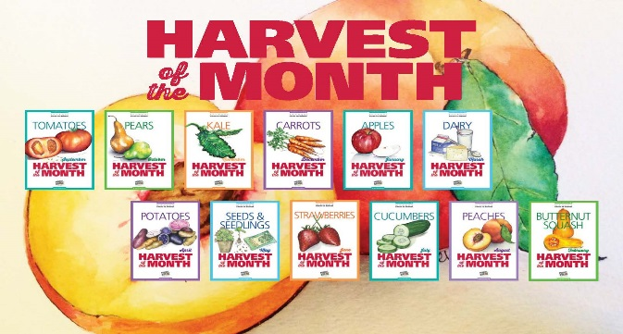
Special events celebrating national food days and seasonal flavors. We love highlighting fresh produce on our menus through our Farm2School theme, and special events that showcases fresh, seasonal flavors.
Our Feed Your Potential 365 program (www.fyp365.com) which provides delicious recipes, nutrition news, and health insights to help support wellness at school and at home.

Sample menu’s, review Healthy School Guidelines, learn about Farm 2 School, provide feedback, and create menu’s by joining the LPS Food and Nutrition Advisory Committee. Sign up by emailing FoodServices@lowell.k12.ma.us

Menus will be available on the LPS website at https://www.lowell.k12.ma.us/Page/4374

We can’t wait to serve your student(s)!

Best wishes for a successful 2021-22 school year,

